

**Senior Design Project**

**THE DESIGN FOR A DEBRIS CLEARING VESSEL**

ENGE476 Senior Design Project I

Department of Engineering and Aviation Sciences

University of Maryland, Eastern Shore

Mohsin Mehmood

Hafeez Shittu

Project Advisor, Dr. Lei Zhang

Submitted

Mon. Day, Year

Special notice for formatting:

1. Don’t add any blank rows. Use spacing or page breaks.
2. Every figure or picture inserted in the text, must be accompanied with the caption and detailed description.
3. Keep the formatting consistent (learn and apply the MS ‘Styles’ in formatting).
4. The final report didn’t meet the basic formatting requirements won’t be accepted.

List of Contents

Special notice for formatting: 2

1. Don’t add any blank rows. Use spacing or page breaks. 2

2. Every figure or picture inserted in the text, must be accompanied with the caption and detailed description. 2

3. Keep the formatting consistent (learn and apply the MS ‘Styles’ in formatting). 2

4. The final report didn’t meet the basic formatting requirements won’t be accepted. 2

Table of Contents 3

Abstract 2

1. Introduction 3

1.1 Backgound/Motivation 3

1.2 Objective 3

1.3 Design Requirements 3

1.4 Design Constraints 3

1.5 Design Methods 3

2. Project Description 4

2.1 System Description 4

2.2 System Diagram 4

2.3 System Functions 4

3. Implementation Plan 6

3.1 Tasks 6

3.2 Team Organization 7

3.2.1 Responsibility of Team Member 1. 7

3.2.2 Responsibility of Team Member 2. 7

3.3 Timeline/Milestones/Delivery Plan 7

4. Implementation 8

4.1 Implementation of Task 1. 8

4.2 Implementation of Task 1. 8

5. Conclusion. 9

Acknowledgement 10

Appendix 11

A. Component Specs 11

1. Specs of Arduino Due 11

2. Specs of Raspberry Pi 11

B. Source Code. 11

1. Source Code of Graphic User Interface 11

2. Source Code of Robotic Arm 11

REFERENCES 12

List of Figures

Table 1. Project Timeline and Delivery Plan 9

List of Tables

Abstract

The principle objective of this project is to design an autonomous marine vessel, use machine learning and target recognition to collect floating plastic bottles in a pond, lake and streams. The motivation behind this project is to find a cheaper and efficient solution for clearing certain water bodies (lakes, ponds, streams). By utilizing autonomous control, the vessel can operate freely and through machine learning, it can target plastic bottles and collect it. The mechanical design stages of any floating body consists of “Imagining and analyzing”, “Concept Design”, “Principle Design and GA drawings”, “CAD design and analysis”. The electrical design stages for components and control system consists of “…….Temmi……” Most of the time in each task will be spend on research. Mechanical design will require the weight calculations, Hydrostatics study, Flow analysis, FEM analysis using a CAD software (Solid Works). This will further help improve our design. The goal for Mechanical design is to ensure the body will float and will be stable under applied force. “Temmi”

1. Introduction

Here give a very brief explanation of what you are going to develop during the project with a few sentences.

## Backgound/Motivation

Plastic never goes away. And it's increasingly finding its way into [our oceans](http://www.biologicaldiversity.org/programs/oceans/index.html) and onto our beaches. In the Los Angeles area alone, 10 metric tons of plastic fragments — like grocery bags, straws and soda bottles — are carried into the Pacific Ocean every day. Today billions of pounds of plastic can be found in swirling convergences making up about 40 percent of the world's ocean surfaces. Plastic waste in lakes, ponds and smaller water bodies accumulate differently than plastic waste in oceans, Plastics can end up in a different place from where the plastic originated due to the pattern of lake currents. It is likely that some cities pollute more plastic than what ends up on their shores. Though plastics that enter a lake may disappear from view, much of the waste can be seen and has many effects on the lives around it. Some of the reasons for Plastic control in lakes and ponds is following:

* Unwanted Migration:

Migration has been in occurrence for as long as the existence of living things on the planet. Although migration is essential for survival, it has proven to be a major source of Biological pollution in man and animal. There is a variation in the immunity of animals, when animals migrate together to the same place, they are exposed to body fluid and waste of one another and to the genetically inferior species; contact with a wastage might lead to an explosion in illness or even death. A lot of animals are extinct due to biologically contamination due to MIGRATION.

* Chemical contamination:

When fertilizers and pesticides are used for Agricultural purposes, it exhibits the benefits of chemical advancements by improving yield but unfortunately, this chemicals are a major source of pollution. When rain falls, the fertilizers and pesticides are swept by flood into the water bodies and this has a detrimental effect on the aquatic animals and plant lives. When pesticides meant to kill off pests flow into the water body, they become harmful to the fishes in the lakes or ponds which might lead to death in aquatic life. Fertilizers that flow into the water bodies can increase the fertility of the water and cause a large growth of algae. This in turn creates a canopy on the water surface which deprives the plants and animals of sunlight and Oxygen.

* Marine mammals:

Marine mammals ingest and get tangled in plastic. Large amounts of plastic debris have been found in the habitat of endangered Hawaiian monk seals, including in areas that serve as pup nurseries. Entanglement deaths are severely undermining recovery efforts of this seal, which is already on the brink of extinction. Entanglement in plastic debris has also led to injury and mortality in the endangered Steller sea lion, with packing bands the most common entangling material. In 2008 two sperm whales were found stranded along the California coast with large amounts of fishing net scraps, rope and other plastic debris in their stomachs.

## Objective

The objective of this project is to design a Catamaran (Dual Hull) marine vessel capable of detecting 500 ml plastic bottles within 1 meter radius and collect them using machine learning.

## Design Requirements

The Design Requirements specified for this objective are as following:

1. The main frame of the vehicle should be able to support up to 60 lbs. of total load, including the Payload up to 20 lbs. and 25 lbs. of vehicle itself.
2. The motors should drive the vehicle with the velocity of 5 miles per hour.
3. The Design must be cost efficient.
4. Recognize floating plastic bottles using machine learning.
5. Should recognize the target (Volume 500ml, height 23.50cm, diameter 6.58, max weight .40g and function intelligently.
6. Based on the size of the collection chamber, the boat should be able to collect up to 35 empty water bottles.

## Design Constraints

In this system design, the design constraints are as following:

1. The main frame of the boat should be within 4ft * 3ft * 2ft (L*W*H).
2. Due to lack of funding, the overall budget for the design should be under 100$.
3. Limited Resources.
4. Easy to assemble.

## Design Methods

For this marine vessel, the design methods include mechanical and electrical design. First we will identify all the mechanical methods required and will be used in this design. The mechanical design methods are as following:

Research Various Boat designs

Preliminary Boat designs

Weight Calculations

Hydrostatic evaluation

Fluid Dynamics analysis

CAD Simulation

Flow Analysis

FEM Analysis

Building a Prototype.

Temmis’s Part

1. Project Description

In this section you are going to add more details of 'what' and answer the question 'how'.

## System Description

The system description is different to objectives. The description is more from inside, talks about what is inside the system. For example: "The vehicle is controlled by the microprocessor Arduino, driven by the battery, navigated by …"

## System Diagram

Draw a system diagram here. The diagram should include every components and show there relationships. For complex system you can have multiple system diagrams, for example, the vehicle mechanical system diagram and electrical system diagram. Or if you have several subsystems, you can also draw diagrams for each of them.

Please make sure you marked the name/function of each component on the diagram, for example, 'motor' or 'wireless receiver'.

You should also put descriptions of every major component here.

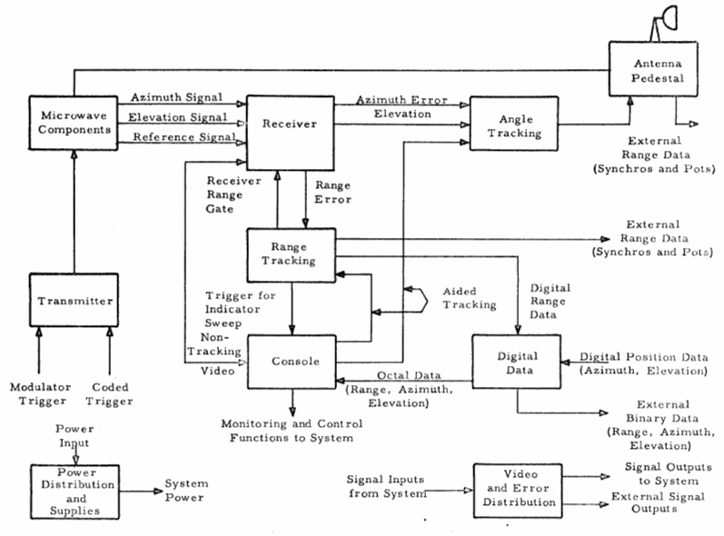

1. System Diagram: (a) main system, (b) subsystem1, and (c) subsystem2.

## System Functions

Here you need to clearly define every function and every state of the system. Make you’re your state graph is complete. For example:

"

1. When the caller press a button, first the message will show on the display of the device with the caller, also the message will be coded together with its ID and send to the callee.
2. …

"

1. Implementation Plan

## Tasks

The design methods used in this process are converted into main tasks and their sub-tasks. Since this is a group project, there will be tasks based on mechanical design and then the electrical designs. They are as following:

* Task 1. Research Basic Boat design
  + Subtask 1. Research

The first main subtask is to research various boat designs and how they work.

* + Subtask 2. Identify suitable boat design

The second subtask is to identify a design based on research.

* Task 2. Preliminary boat design
  + Subtask 1. Hand drawings

Draw basic design which was identified using Task 1. Come up with different designs to choose from.

* + Subtask 2. Compare and contrast

Compare and contrast all the designs. Learn about their Pros and Cons, Based on that choose the most efficient design.

* Task 3. Weight Calculations
* Subtask 1. Calculate volume

Calculate the volume of each part so we can calculate the mass of each part and then the whole system.

* Subtask 2. Calculate Mass

Calculate the mass using the volume from subtask 1 and each parts material density.

* Task 4. Hydrostatic study
* Subtask 1. Calculate Buoyancy force

Use the volume, mass to calculate the buoyant force of the floating ship.

* Subtask 2. Calculate center of buoyancy

Use the area submerged to find the center of the buoyant force

* Subtask 3. Calculate Displacement

Calculate the volume of the water displaced.

* Subtask 4. Calculate center of mass

Identify and calculate the center of mass of the whole system

* Subtask 5. Calculate meta centric height

Find the metacentric height based on the COM and COB

* Subtask 6. Calculate stability

Identify the stability of the ship using the angles 0-15 degrees to ensure the boat will not tip over and the system will be stable.

* Task 5. Fluid dynamics
* Subtask 1. Calculate drag

Calculate the drag of the ship in fluid.

* Subtask 2. Calculate lift

Calculate the lift of the ship in fluid.

* Task 6. CAD simulations
* Subtask 1. Flow analysis

Simulate the boat in fluid using computer aided design software, In this case we will use Solid-works.

* Subtask 2. Fem analysis

Simulate the boat stress analysis to identify if the system will fail or not.

* Task 7. Build a Prototype
* Subtask 1. Order the components
* Subtask 2. Build the boat

## Team Organization

As identified before this project is split into two equal parts: Mechanical design and the electrical design. The mechanical design will be the responsibility of team member 1 and the electrical design will be the responsibility of Team member 2.

### Responsibility of Team Member 1.

Responsibilities of Team member 1 are as following:

* Task 1
* Task 2
* Task 3
* Task 4
* Task 5
* Task 6
* Task 7

### Responsibility of Team Member 2.

…Hafeez part

## Timeline/Milestones/Delivery Plan

Please prospect the timeline to deliver the results of each task/subtask.

Please schedule your project to no more than 22 weeks from now.

1. **Project Timeline and Delivery Plan**

|  |  |  |  |
| --- | --- | --- | --- |
| Time | Task | Comments | Responsible Personnel |
| Week 1-4 | Choosing topics | Week 1 through 4 were spent looking for the topic. | Mohsin Mehmood, Hafeez Shittu |
| Week 5 | Finish task .11  Started subtask 7.1 | Research                             Electrical Layout | Mohsin Mehmood  Hafeez Shittu |
| Week 6 | Finish Subtask 1.2  Finished subtask 7.1 | Identify suitable boat design  Electrical layout | Mohsin Mehmood  Hafeez Shittu |
| Week 7 | Finish Subtask 2.1  Started subtask 7.2 | Hand drawings  Power Analysis( identifying components) | Mohsin Mehmood  Hafeez Shittu |
| Week 8 | Started Subtask 2.2  Finished subtask 7.2 | Compare and contrast  Power Analysis(duration of operation) | Mohsin Mehmood  Hafeez Shittu |
| Week 9-11 | Finished Subtask 3.1,3.2,3  Finished  8.0 | Calculate volume, mass, displacement  Pixhawk Configuration | Mohsin Mehmood  Hafeez Shittu |
| Week  12-15 | Finished Subtask 4.1-4.6  Started 9.0 | Calculate displacement, center of mass, MC height, stability  Target recognition | Mohsin Mehmood  Hafeez Shittu |
| Week 16 | Finished Subtask 5.1,5.2 | Calculate drag and lift | Mohsin Mehmood |
| Week 17 | Finish Subtask 6.1 | Flow analysis | Mohsin |
| Week 18- | Finish subtask 6.2 | Fem analysis | Mohsin |
| Week 19-32 |  | NEXT SEMESTER |  |

1. Implementation

For each task/subtask, create a section and add tech details of how it is implemented.

## Implementation of Task 1.

Research:

When it comes to boat, there are countless ways to design it. This is based on the functions of the boat it-self. So, the first step for this subtask was to research and understand what different types of boats are capable of and which design is most suitable based on our design requirements.

“A boat is a small vessel which has been specifically designed for navigating in near-shore areas or inland waterways.” Though there is a thin line between a ship and a boat, t[here are quite a few differences which set both of them apart.](https://www.marineinsight.com/types-of-ships/7-differences-between-a-ship-and-a-boat/) Boats can be classified into three main sections as follows:

1. Unpowered or man-powered (like rafts, gondolas, kayaks, etc.),
2. Sailboats (sail-propelled)
3. and Motorboats (engine-powered)

Since, we wanted our vessel to move slowly through the water, i was able to shrink the boats to research from drastically. The boat designs considered are as following:

## 

## Banana Boats

As the name suggests, it is banana-shaped and inflatable and easily floats on water. It does not have an inbuilt motor system. A banana boat has a capacity to seat around three to ten people.

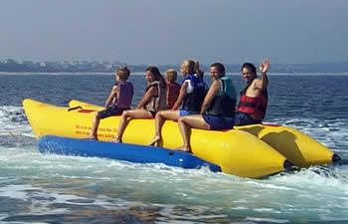

**Fig “Banana boat”**

The reason for this design consideration was its ability to carry heavy payloads. With the addition of right electrical motors we can turn this passenger boat design into a debris collecting vessel.

**Hydrofoil boats:**

The hydrofoil system incorporates the use of wings or lifts(Pontoons) to raise the boat from the surface of the water and move forward.

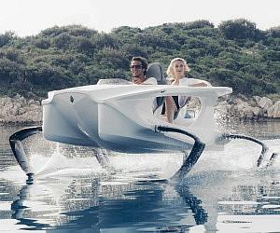

Fig Electric Hydrofoil Boat

The reason for this design consideration was solely because of the empty cavity in the front, which we can incorporate into the collection bin for the vessel.

**Catamaran Boats:**

According to the Google Definition: “A catamaran (/ˌkætəməˈræn/) (informally, a "cat") is a [multi-hulled](https://en.wikipedia.org/wiki/Multihull) [watercraft](https://en.wikipedia.org/wiki/Watercraft) featuring two parallel [hulls](https://en.wikipedia.org/wiki/Hull_(watercraft)) of equal size. It is a geometry-stabilized craft, deriving its stability from its wide [beam](https://en.wikipedia.org/wiki/Beam_(nautical)),”

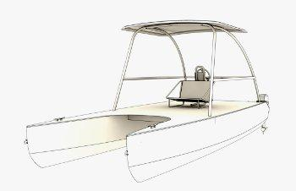

Fig Catamaran Boat

The stability is mainly due to equal sized hull on each sides. The catamaran boat with three hulls is also plausible in real life, but for our design purpose, we need to focus on two hull catamaran design.

**Pontoons and its advantages:**

Due to our design requirement of collection of at least 25 pounds, i used pontoon boat design for our vessel due to its many advantages. Some of the advantages are as following:

## Ease of Use/Maintenance

Pontoons can be made from any light materials. Aluminum is the ideal material used for industrial pontoons. We are planning to use Pink insulation foam to build our pontoons, this is then be reinforced using fiberglass sheets and Epoxy resin. Working with Pink foam is easy and it’s very easy to maintain.

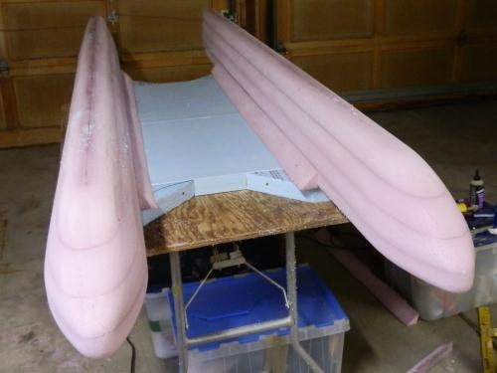

Fig Pontoon built using Pink foam

## Longevity:

This is one of the most important factor for using pontoons. Pontoons built using Pink foam can last longer and is very easy to maintain. The boat can be left in water for a long period of time can still function without any problems.

## Building Cost and Storage:

Building cost for pontoons using pink foam is very low, 80 dollars to be exact. This includes the Pink foam, epoxy resins, Fiberglass sheets. Pontoon boats are also known for their storage capabilities. Due to certain design requirements, using pontoons will provide us empty area which will function as the collection bin.

## Implementation of Task 2.

## Earlier designs:

To start the project, we started with the major component of the build, that would be task 1 (Subtask 1). This Subtask includes a rough 3-D diagram of the parts of the system, as well as the whole 3-D design of the vessel, itself. Working on the rough design means, we have to identify all the dimensions, Size and Materials which meet the design requirements one way or the other.

Doing the Subtask 1 was the hardest part in this project, that’s because every-time I proposed a design, I got criticized. Here are some of the earlier designs below:

**First design:**

The first design for the boat was poorly hand sketched based on mine and my partners idea, most of the later and final design follow the same pattern of design. The first design is the figure below:

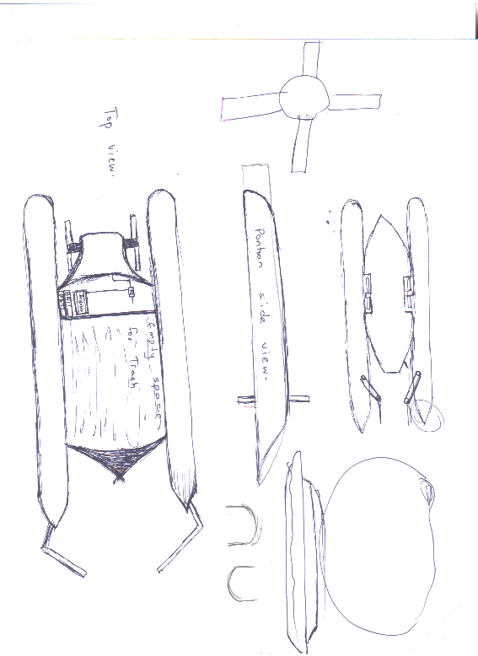

Fig Shows the “First Design”

**Earlier design 1:**

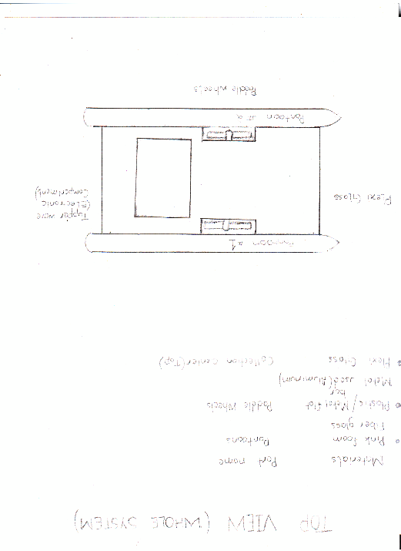

Fig Earlier design 1 “Vessel Top view”

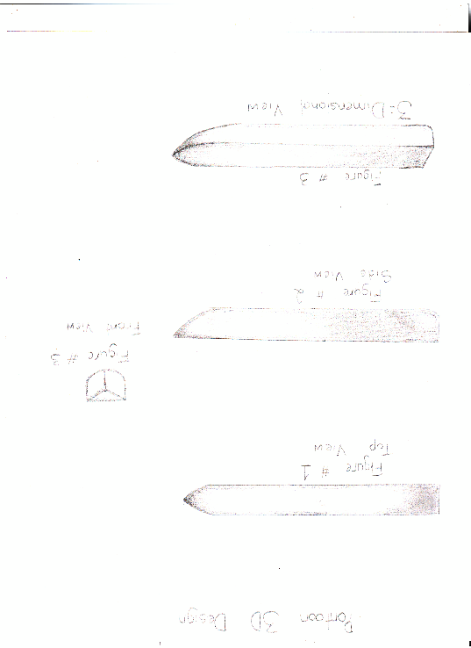

Fig Earlier design 1 “Pontoon”

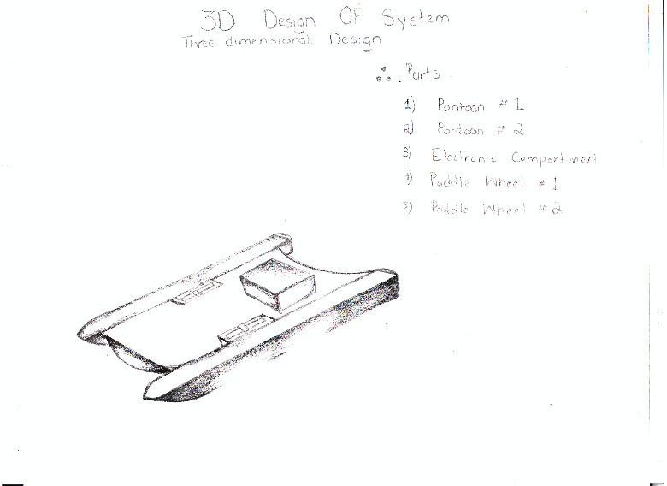

Fig Earlier design 1 “3D System Drawing”

**Cons for Earlier design 1:**

The first design seems to meet all but two design requirements which are as following:

1: Lack of storage:

Due to lack of storage space, we identified that this design can not hold more than 16.6 pound of weight.

2: Shallow ends collection:

The second reason for this design failure was its inability to collect debris from the shallow ends which is one of the most important design requirements.

## Earlier Design 2:

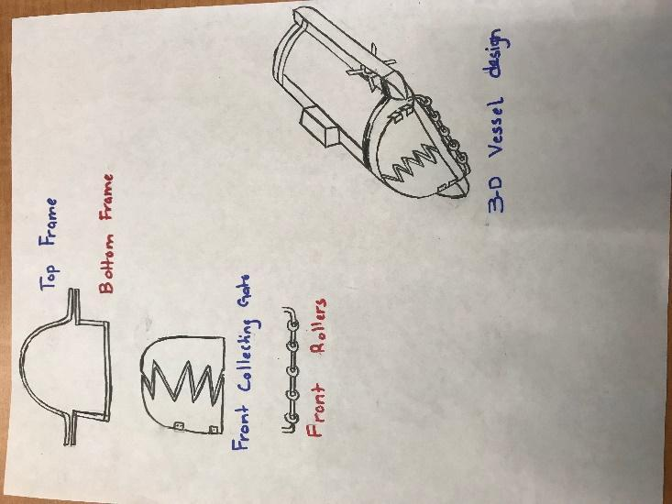

Fig Earlier design 2 “3D drawing”

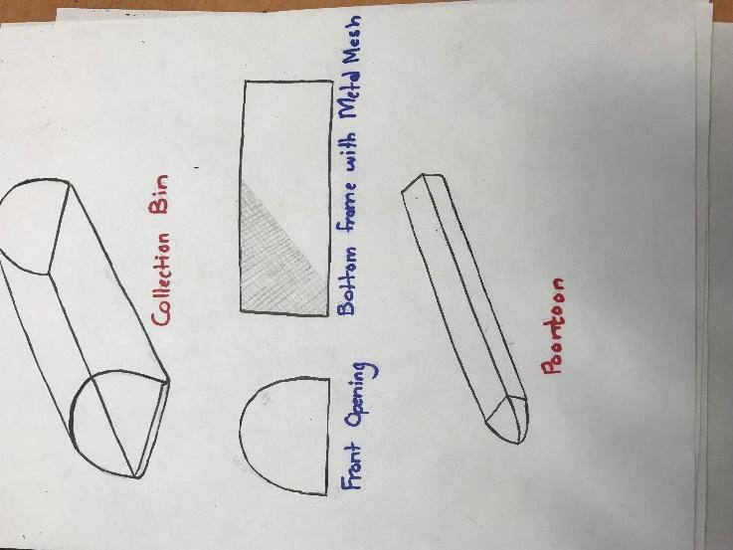

Fig Earlier design 2 “Pontoon & Collection Bin”

**Cons for earlier design 2:**

In my opinion, this was a valid design and met all the design requirements, but due to constant pressure from my partner and instructor, the design was completely changed. The argument against this design “it’s too close to a boat design, design something innovative.”

**Earlier design #3**

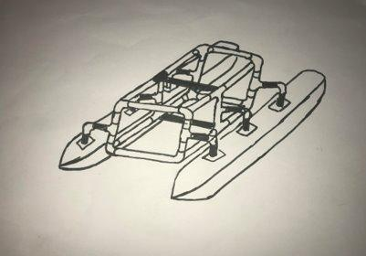

Fig 3rd Design 3D drawing

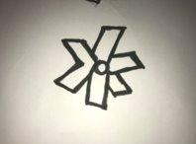

Fig 3rd design “Paddle Wheel”

Based on all the research and continuous trial and error, i was able to come up with a final design, which followed all the design requirements, it was also approved by the instructor himself.

**Cons for “Earlier Design 3”**

The design has to be evaluated and after evaluating this design i realized it won’t be efficient.

**Pros for “Earlier Design 3”**

The pros for the final design are as following:

1: The frame is very light.

2: The pontoons are also very light.

3: This is cost-efficient.

4: The parts can be re-assembled for storage.

5: Malleable parts.

**Final Design:**

Below are some images to show the new boat design.

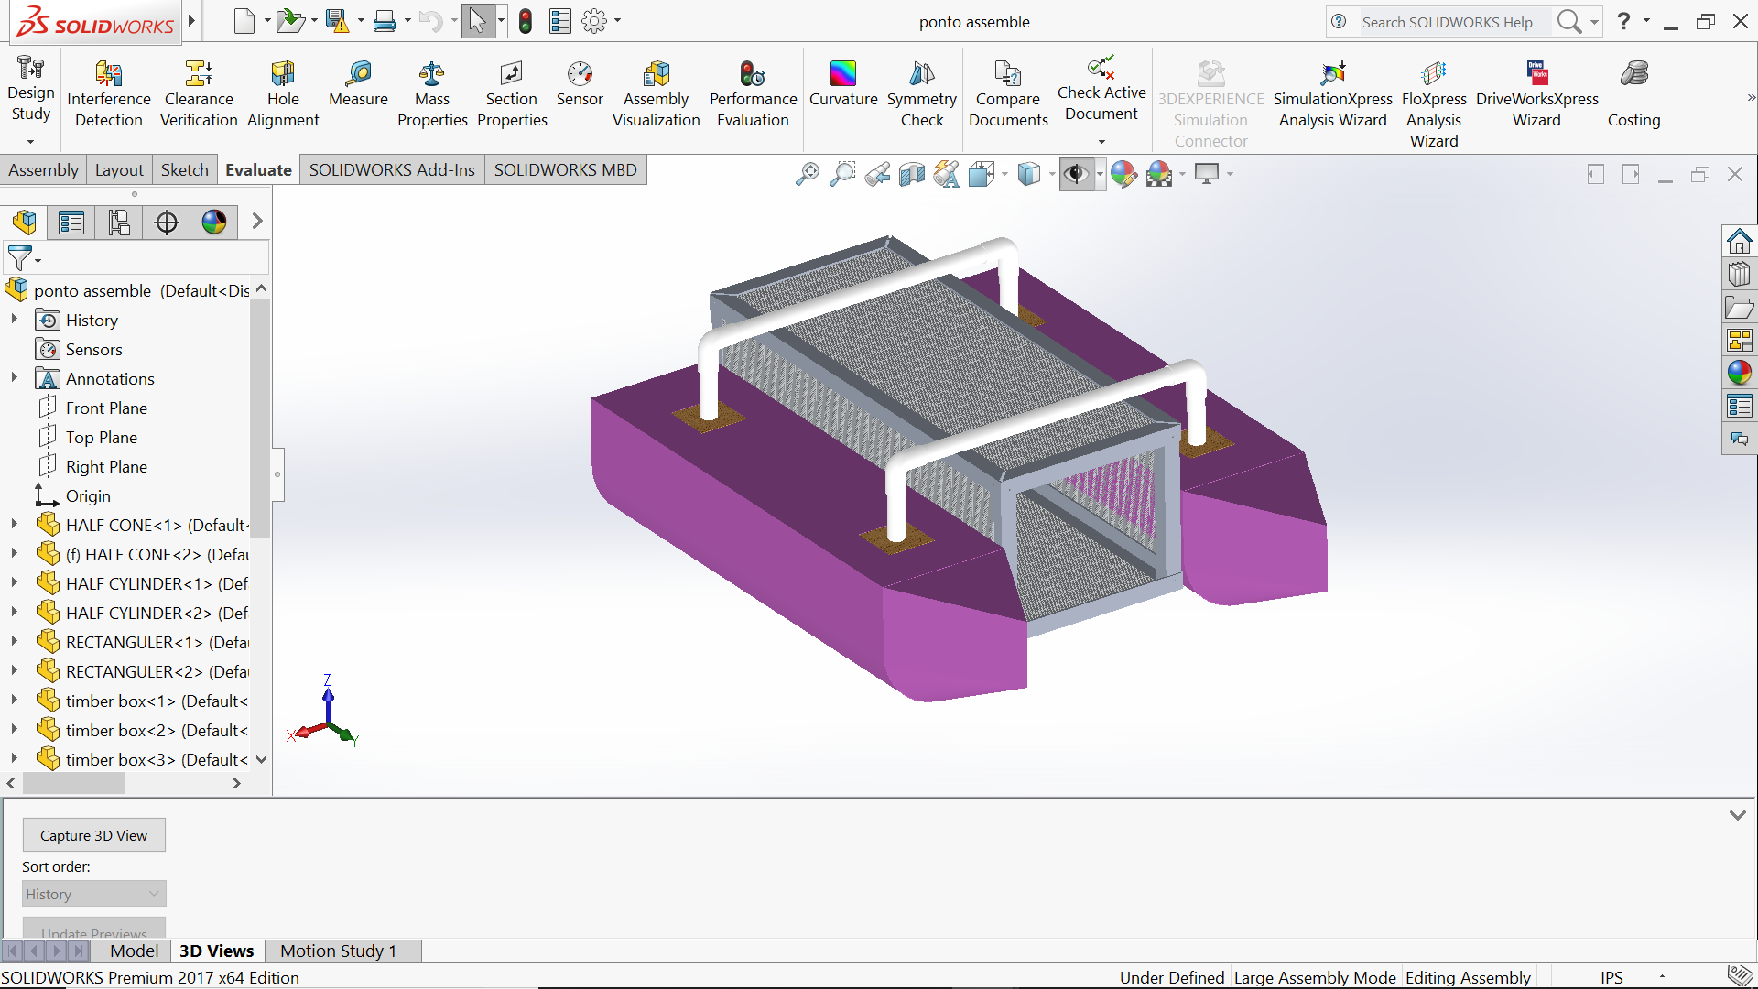

This part required research on the best possible materials that can be used for this built. The following are the characteristics for the materials we can use:

1: Light-Weight:

The material should be lightweight, this will cover the design requirement for ease of use. The light weight implies that less force is required to move this vessel around.

2: Strength:

Strength is a big factor when considering materials as well, since the vessel should be able to hole 25 pounds or more of debris without the system sinking. This also causes a problem since many light materials are not strong.

3: Cost efficient:

The material we use have to be cost efficient, since this product is to save money and lower expenses.

4: Ease of access:

Since, we are university student, we also had to make sure that the materials we use can easily be found in local hardware stores.

**Materials:**

Based on all the factors above i was able to identify the following materials:

1: PVC Pipes:

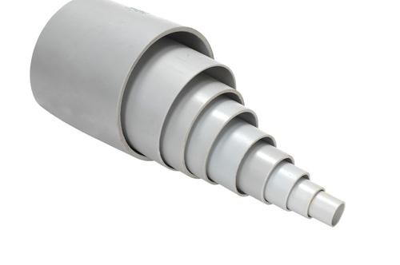

Fig Different sizes of right PVC pipes

**Pros:**

The pros for using PVC pipes are following:

1: Superior corrosion resistance

2: Cheap

3: Good heat resistance

4: Strength

5: High pressure resistance

6: Inert to most mineral acids, bases and salts.

7: Ease of access

8: Choice of size

## Pink Foam:

Pink foam or Polyurethane panels are what we will use to build the pontoons of the vessel:

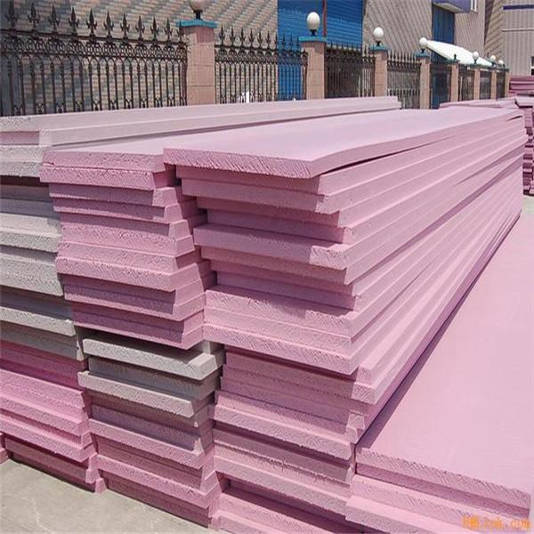

Fig Pink Insulation Foam

**Pros for Pink foam:**

Some of the pros of using Pink foam are as following:

1: Thermal conductivity

2: Moisture sensitivity

3: Compressive strength

4: Ease of installation

5: Durability - resistance to degradation from compression, moisture, decomposition, etc.

6: Ease of replacement at end of life

7: Cost effectiveness

## Implementation of Task 3.

In order to approach this task we must identify the formulas used:

**Formulas Used:**

Different shapes have different volume formulas. We used the ones following to find volume for each part of the boat.

**1: Rectangular prism**

We used this to find volume for rectangular parts of pontoon.

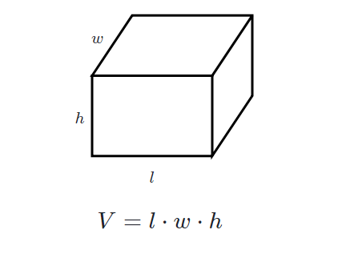

Fig Formula for Rectangle Volume

**2: Triangular Prism**

This was used to find the volume for front part of pontoon.

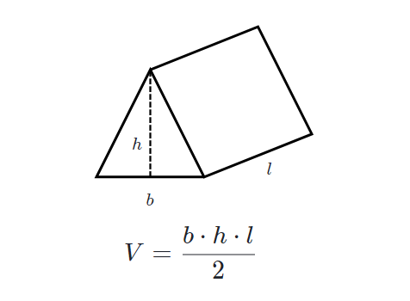

Fig Triangle volume Formula

**3: Cylinder**

This was used to find the half cylinder shape of the pontoon.

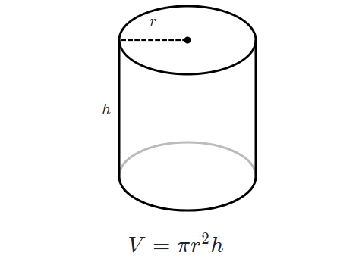

Fig Cylinder Volume Formula

**4: Cone**

This was used to find the front conic volume for pontoon.

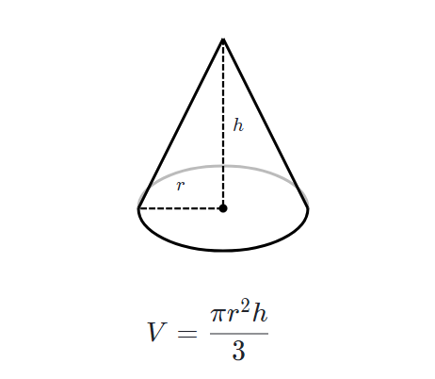

Fig Cone Volume Formula

**Density Formula:**

Formulas used:​

* Density = Mass / Volume​

Or​

* d = M / V​
* Volume of Cylinder: Pi * r^2 * h

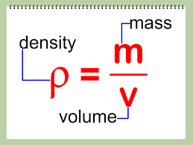

Fig Density formula

Key-Terms​

* P = represents density
* m = represents mass
* v = represents volume

This formula is used to identify individual mass.

**Finding Buoyant force:**

The name of this upward force exerted on objects submerged in fluids is called the buoyant force. So why do fluids exert an upward buoyant force on submerged objects? It has to do with differences in pressure between the bottom of the submerged object and the top. Because pressure

(Fb=rho gh)

exerted increases as you go deeper in a fluid, the force from pressure exerted downward on the top of the body will be less than the force from pressure exerted upward on the bottom of the body. that is why the buoyant force is necessary for a boat design:

Buoyant force = ρgV​

Where:​

ρ is the density of the fluid​

g is the gravitational acceleration​

V is the volume of the fluid displaced

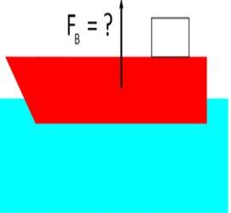

**Fig Buoyant force**

* Density of water = ​
* g = 9.81 m/s^2​

**Finding volume and mass for each part:**

**Half Cylinder:**

Radius of half cylinder = 0.10160m

Density of foam = 21 kg/m^3

Height of the Half cylinder = 0.7154m

Volume of Half cylinder = (

(3.14 * (0.1016^2) * 0.7154) / 2

= 0.011 m^3

To calculate for two cylinders =

=

= 0.022 m^3

Mass of one cylinder = Volume * Density

Density of Pink insulation foam = 21 kg/m^3

= 0.24213 kg

To calculate mass for two cylinders =

= .48426 kg

**Front cone half Volume and Mass:**

This includes the two half conic sections and the triangular sections on the pontoon.

Total volume = Volume of half cone + Volume of triangular pieces

**>> Half cone Volume**

Radius = 0.101m

Height + 0.203m

Volume of a half cone =

=

**>> Triangular pieces**

Volume of Triangle

= (0.203 * 0.203 * 0.101) / 2

=

Volume for two of each piece since there are two pontoons.

=

=

Mass calculation for the above pieces = Volume * density

= 0.06636 kg

Mass for two of each part in consideration =

= 0.13272 kg

**Wooden Cubes**

**>> Volume of outer cube**

Volume = L * B * H

= 0.076 * 0.076 * 0.076

=

**>> Volume of Inner circle**

Volume =

=

Total volume =

=

=

Mass = v*d

=

= 0.23052 kg

For 4 wooden cubes=

= 0.23052*4

= 0.92208 kg

**Rectangular Blocks * 2**

**>>Volume**

L*b*h = 0.711*0.203*0.101

=0.0145 m^3

Total volume= {volume of rectangular blocks – (volume of 2 3*3*3 blocks)} *2

=

=0.0272m^3

Weight = (0.0136*21)*2

=0.2856kg * 2

=0.5712kg

**PVC pipes 18.5 inches*2/ 4 inches*4**

Volume/mass for 18.5 inches:

So, to calculate the volume for 2 18.5 inch PVC pipes

=

**>> Mass Calculation (18.5 inch PVC)**

Using Density equation =

= 0.0676 kg

For two PVC pipes (18.5 inch)

= 0.0676 * 2

= 0.1352kg

**>> Volume for PVC (4 inches)**

Volume =

For 4 pieces =

**>> Mass Calculation (4 inch)**

Mass =

For 4 Pieces = (0.0145 * 4)

= 0.058 kg

**Elbow PVC Volume and mass calculation**

**>> Volume Calculation**

Volume =

r = outer ring radius

R = radius of curvature

For 4 Pieces of PVC elbows = (1.54 *10^-5 m^3)*4

**>> Mass Calculations (PVC Elbow)**

Mass

=

=0.02002 kg

For 4 PVC elbows =

= 0.02002 * 4

= 0.08008 kg

**Volume and Mass Calculations (Aluminum Angle bar 28 inches)**

**>>Volume Calculations**

Volume =

=

For 4*28 inches aluminum angle bar =

**>> Mass Calculations**

Mass = Volume * Density

= 0.030051 kg

For 4 * 28 inches Aluminum angle bars

= 0.030051 kg * 4

= 0.120204 kg

**Volume and Mass Calculations for Aluminum angle bar (12 inches)**

**>> Volume Calculations**

For four 28 inches aluminum angle bars =

*4

=

**>> Mass Calculations**

Mass = (

= 0.134 kg

For four 28 inches aluminum angle bars

= 0.538 kg

**Mass and Volume calculations For Box aluminum bars**

**>> Volume Calculations**

Volume = Volume of outer cube – Volume of inner cube

For 4 pieces

=

**>> Mass Calculations**

Mass

=

= 0.188 kg

For four pieces = 0.188 kg *4

= 0.752 kg

**Volume and Mass calculations for Aluminum Mesh**

**>> Volume calculations**

Total volume = Volume of whole body – Volume of displaced holes

=

**>>Mass Calculations**

Mass =

= 2.85 kg

**Mass Calculations for the screws**

Standard weight for the screws used = 0.00585 kg

For 20 screws

= 0.00585 * 20

= 0.0117 kg

Total volume Table

|  |  |
| --- | --- |
| **Parts** | **Volume** |
| Half Cylinder |  |
| Front Cone |  |
| Wooden Cubes |  |
| Rectangular blocks |  |
| PVC 18.5 inch |  |
| PVC 4 inch |  |
| PVC Elbow |  |
| Aluminum Angle Bar 28 inch |  |
| Aluminum Angle Bar 12 inch |  |
| Aluminum Box Bar 12 inch |  |
| Aluminum Mesh |  |
| **Total Volume** |  |

Total mass Table

|  |  |
| --- | --- |
| **Parts** | **Mass** |
| Half Cylinder | 0.48426 kg |
| Front Cone | 0.13272 kg |
| Wooden Cubes | 0.92208 kg |
| Rectangular blocks | 0.5712 kg |
| PVC 18.5 inch | 0.1352 kg |
| PVC 4 inch | 0.058 kg |
| PVC Elbow | 0.08008 kg |
| Aluminum Angle Bar 28 inch | 0.120204 kg |
| Aluminum Angle Bar 12 inch | 0.538 kg |
| Aluminum Box Bar 12 inch | 0.752 kg |
| Aluminum Mesh | 2.85 kg |
| Screws | 0.117 kg |
| **Total Mass** | 6.760744 kg |

**Implementation of Task 4**

**Mass breakdown of the ship:**

Total weight of the building materials = 6.760744 kg =>14.8736368 pounds

The mass of electronics = 10.17 pounds

Maximum Mass of the payload = 25 pounds

Total weight of the boat including dead weight and payload weight = 50 pounds => 22.72727 kg

**Total Water Displacement**

**Volume of Boat Base Parts**







* + Total water displacement should be 0.0227 cubic meters.
  + But, 0.0227<V1+V2. Hence, both cylindrical and conical parts are not fully submerged in water due to the 22.727 kg weight.
* If height of excessively displaced water is h,









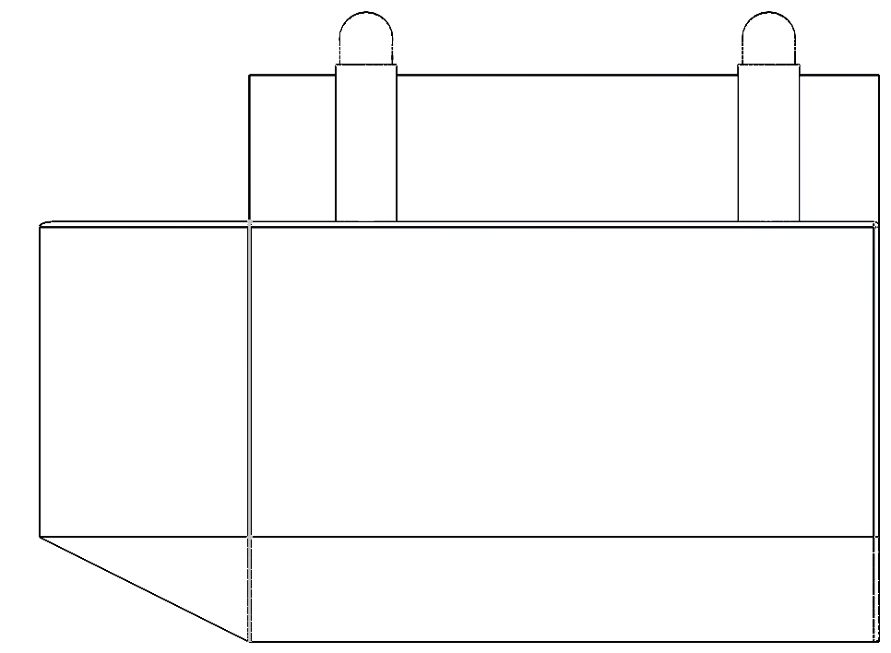

**0.109 meters**

**Mass and Floating Properties**

There are several materials used in boat components.

|  |  |  |
| --- | --- | --- |
| **Part** | **Material** | **Density (lbs-inch-3)** |
| **Base** | Styrofoam | 0.001301 |
| **Connecting tubes** | PVC | 0.050578 |
| **Container** | Aluminum Plates + Mesh | 0.097544 |
| **Top Mesh** | Aluminum Plates + Mesh | 0.097543 |

* Center of mass

Since the density of the Styrofoam is extremely low whereas the volume of the PVC parts is negligible, one can assume that the center of mass of the boat is the one of the container.

* Center of buoyancy

The distance between the center of mass of semicircle and the center of mass of the respective circle is the following:

.

One can calculate the x and z coordinates of the center of mass of the cone part as follows

 

Where,

.

Hence,

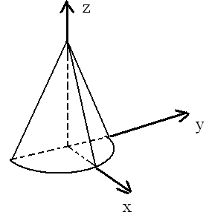

In the case of the semi-cylinder, the coordinates of the center of mass are the following:

m, , meters.

Since h<<0.1016 m, one can assume that the center of the mass of the part of the semi-cylinder that is not submerged has such the coordinates m, m, and. Hence, for the coordinates of the center of mass of the submerged part of the cone, one can write the following:

,, and  where  and . Hence, m and m.

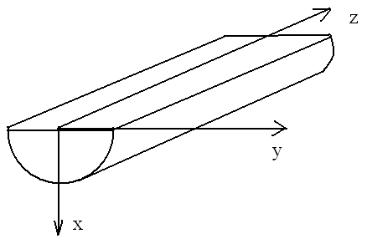

Assuming that the coordinate origin is chosen on the top edge of the bottom part as shown below, one can calculate the coordinates of the center of the buoyancy as follows

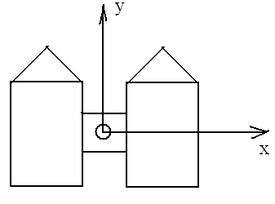

|  |  |  |  |  |
| --- | --- | --- | --- | --- |
| Part | , cubic meters | , meters | , meters | , meters |
| Left semi-cone | 0.000931 | -0.1396 | 0.4295 | -0.0389 |
| Right semi-cone | 0.000931 | 0.1396 | 0.4295 | -0.0389 |
| Left semi-cylinder | 0.01043 | -0.1396 | 0 | -0.0475 |
| Right semi-cylinder | 0.01043 | 0.1396 | 0 | -0.0475 |
| Center of the buoyancy |  | 0 | 0.035203 | -0.0468 |
|  |  |  |  |  |

The location of the center of mass (COM) and the center of buoyancy (COB) is shown below:

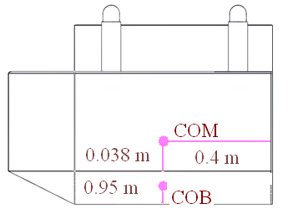

The metacentric radius is the distance between COB and the metacenter. It equals  where  is the second moment of area of the water plane section with respect to the y axis (see the illustration below). As for, it is the total water displacement and equals 0.0227 cubic meters. One can calculate the value of I as follows

.

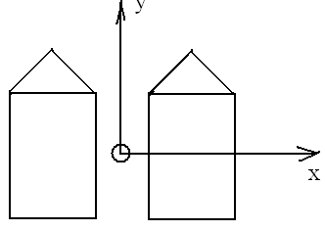

Hence, the metacentric radius equals = 0.336 meters. Since the metacentric height is the distance between the metacenter and COM, it is equal to 0.251 m.

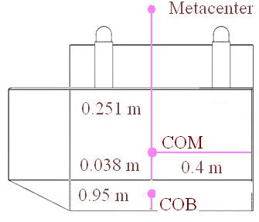

The moment due to the movement of the load equals  where  is the displacement of the load and M is the load mass. Since the load mass equals the one of the boat, th moment due to the shift of the center of mass equals . Hence, the displacement of the load s that corresponds to the tilt angle  has such the value . Thus, if  ranges from 0 to 15°, then the load displacement ranges from 0 m to 0.131 m.

**Stability of the boat**

On Figure 1,, M, G, B, and  are respectively the angle of a heel, the metacenter, the center of gravity, the center of buoyance when , and the center of buoyance when the angle of a heel equals . The stability curve is the plot of the dependence  (see Figure 1). For small values of, one can assert that. In the case in hand,.

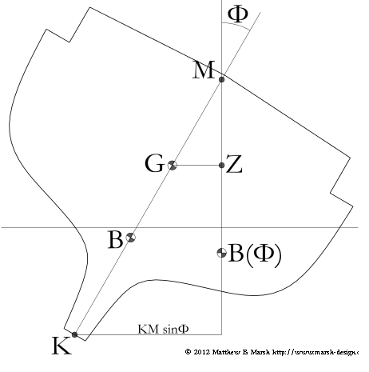

Figure 1 (Marsh, 2012).

**Implementation of Task 5**

As we finish with the hydrostatic evaluation of the design, we will move on to finding out the Drag and Lift forces that will be applied to the design while moving at the velocity of 5mph.

This will compute the fluid dynamics of the design.

**>> Drag and lift forces**

Since the velocity is very small, the flow is the creeping one. Therefore, one can assert that the shape of the boat is streamlined. Hence, the pressure drag vanishes. As for the viscous drag, one usually ignores it calculating the speed of the boat. Hence, the drag force equals zero.

On Figure 2, the hydrodynamic side force is the lift. From Figure 2, it follows that under the condition of the zero drag, the directions of the apprent wind and the true one coinside and are opposite to the boat course. Hence, from the symmetry considerations, it follows that the lift equals 0 too.

But since Evaluating Drag and lift force is an important part of designing a marine vessel, solidworks was used to evaluate drag and lift forces.

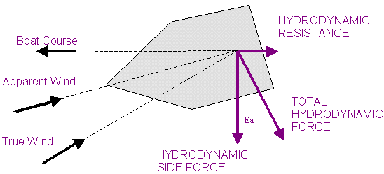

Figure 2 (Evans, n. d.).

**Implementation of Task 6**

Task 6 contains two main subtasks, which are:

**1: Flow simulation**

According to Solidworks: “SOLIDWORKS Flow Simulation. Engineering Fluid Dynamics (EFD) is a new breed of Computational Fluid Dynamics (CFD) software that enables mechanical engineers to simulate fluid flow and heat transfer applications with powerful, intuitive, and accessible 3D tools.”

**2: FEA stress analysis.**

Stress analysis helps us compute our virtual design’s structural analysis, it is used to find the products real world physical behavior.

**Earlier plans:**

At first, only one computer aided design software was going to be used in order to do both FEA and flow simulation. That software is Solidworks. The outdated version 2012 was our only choice, before I bought 2017 Solidworks. The designing of the vessel in Solidworks was simple but time consuming. Most of all, many systems which I used to run the said software couldn’t handle the memory usage. After one month of trial and error I was able to run flow simulation.

**Setting up Flow Simulation:**

All flow simulation steps used for this project are as following:

**1: Cut Section and set up wizard:**

First step was to cut the vessel assembly right on the computed waterline. This helps us not only lower the run time but it also helps us focus on only the submerged parts of the vessel.

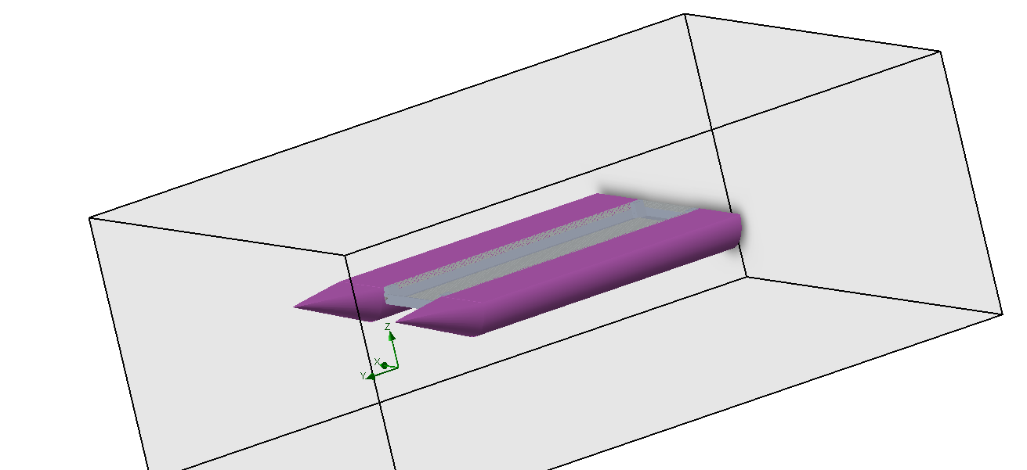

One the body is cut at the water line, setup the wizard for flow simulation, while setting up the wizard, you can apply any kind of liquids, gases that are present in the library. Also during this setup Wizard is when you apply the velocity of the vessel which it will be moving under water in.

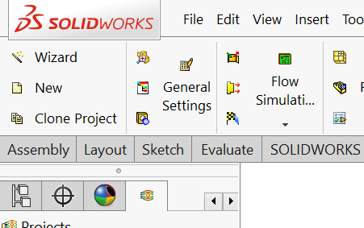

**Project setup:**

Once the Solidworks flow simulation wizard is complete, the next step is to focus on the Project settings, this includes computational domain setup, fluid subdomain setup, Boundary conditions setup, Goals setup and lastly mesh setup:

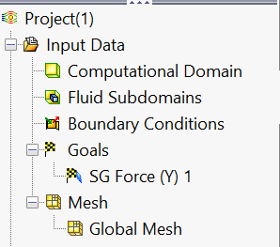

After is setup my computational domain, which included all the cut through body submerged, I moved onto providing this project it’s unique boundary conditions such as buoyancy force, etc. These values were calculated before.

Soon after I set up the goal to find all forces on the conic face of the vessel, this is in-fact our drag force which is being applied to the front of the vessel while it moves at 5 miles per hour.

All the conditions set, we ran the simulation and results are as following:

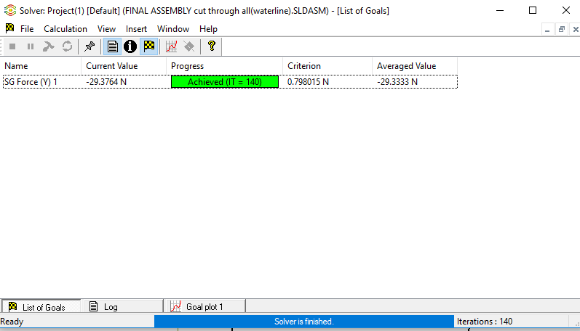

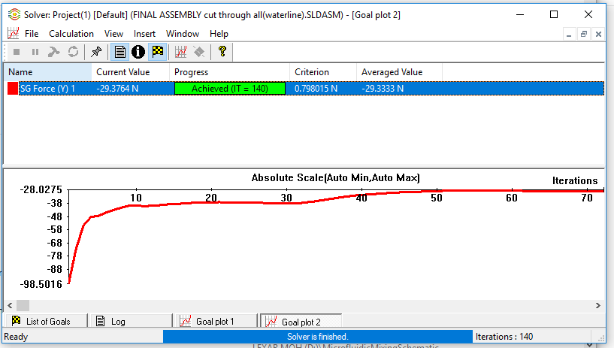

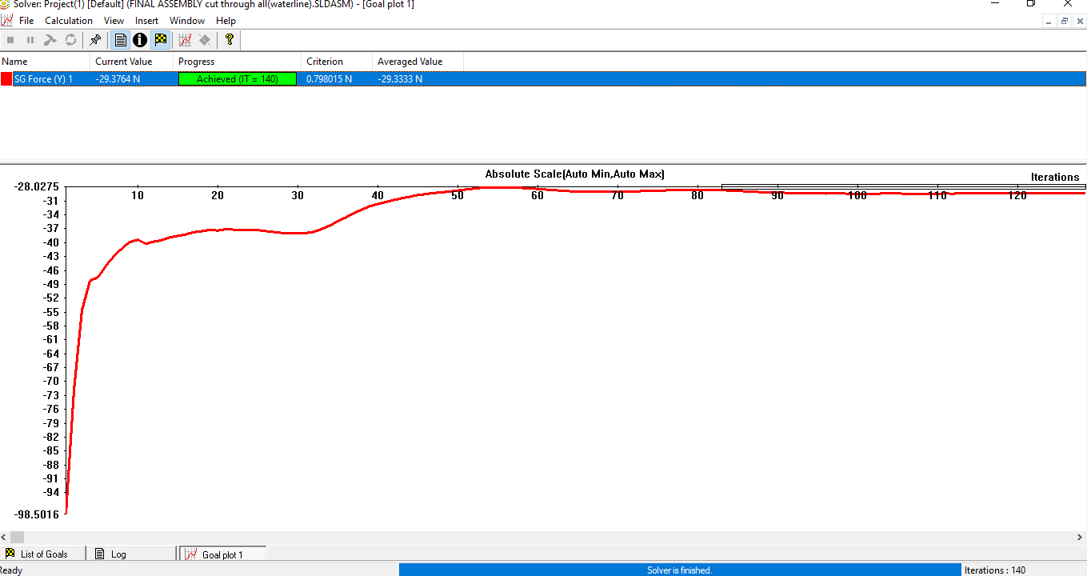

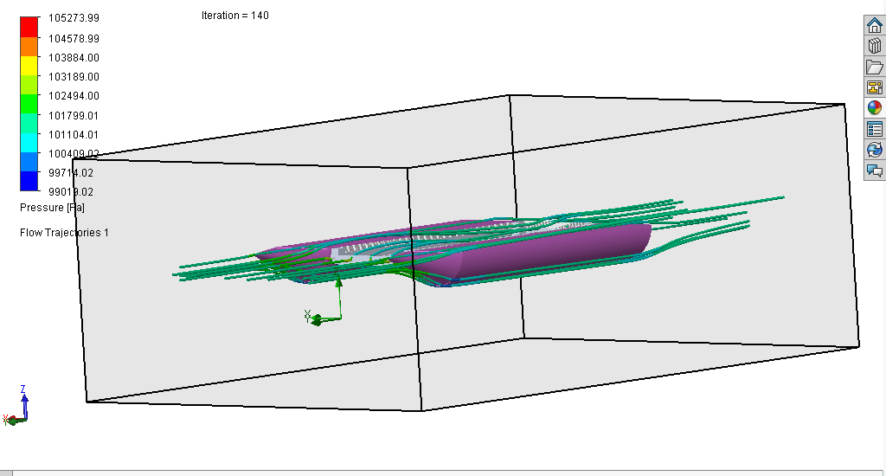

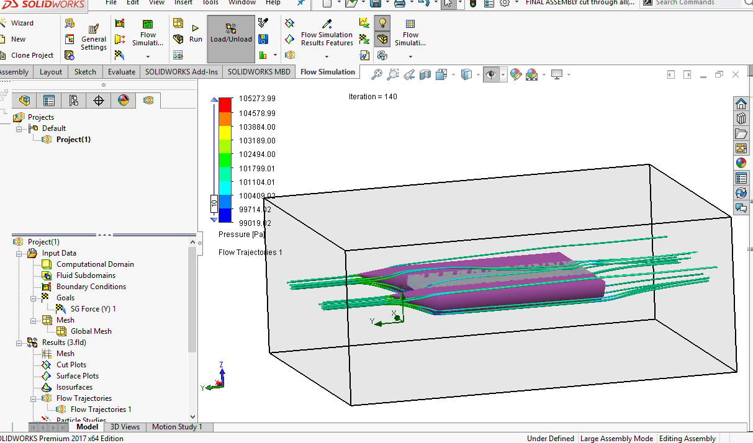

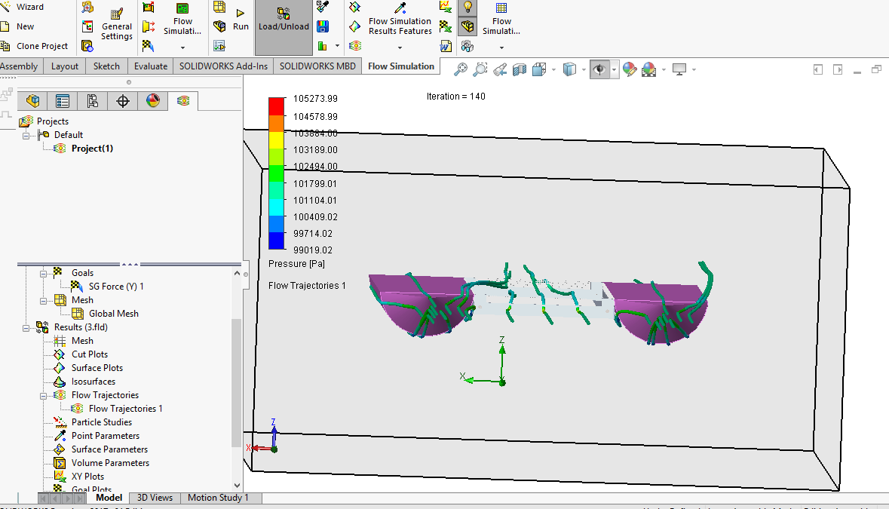

**Results:**

Through this flow simulation, I was able to see the flow of water through the vessel itself, not only that I was able to find Drag force which is about 29.37 N. This value will further help me run the stress analysis. Drag force will also be used to in order to identify the motor and power required to overcome this force.

**FEA analysis:**

Similar to Flow simulation, this was to be done using Solidworks, but after many crashed attempts, we decided to use inventor instead, Inventor meshes the product itself. The main problem with the vessel is the aluminum mesh that is around the collection chamber. Since the system is advanced, I will be running two simulations one without the collection chamber and one with the chamber. The wooden blocks that are supposed to hold the PVC together cannot be identified in inventor, so I ended up using silicon with same weight.

The forces that are applied in this case are following:

1: Drag Force

2: Weight of electronics and cargo

3: Buoyant force

The results showed only one failure point and that is because of the temperature change in silicon we used, the silicon melted and the PVC pipe pulled itself out of the coupling. In the actual vessel we are using oak wood blocks, also we are using epoxy to hold the system together. Epoxy and fixing option is not found in inventor, hence the issues.

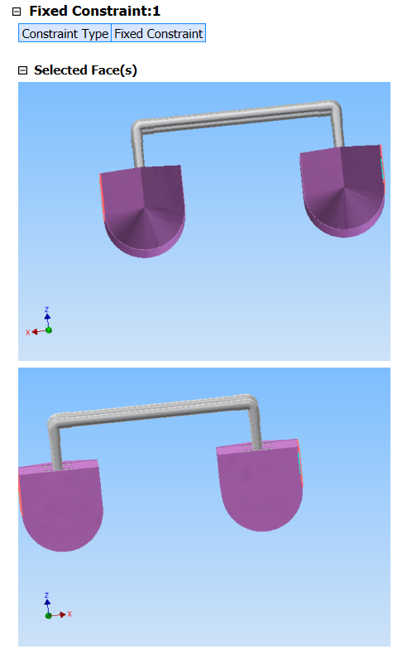

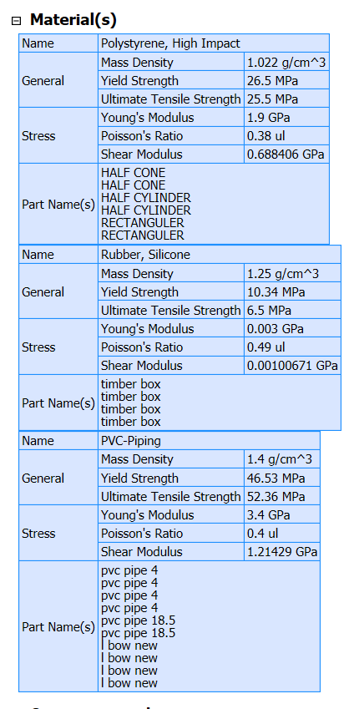

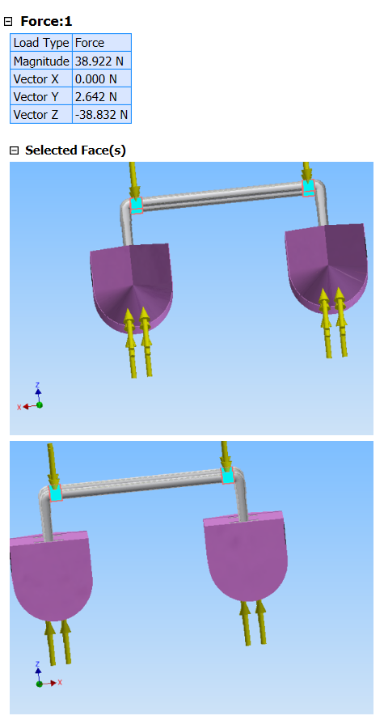

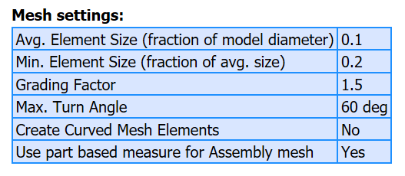

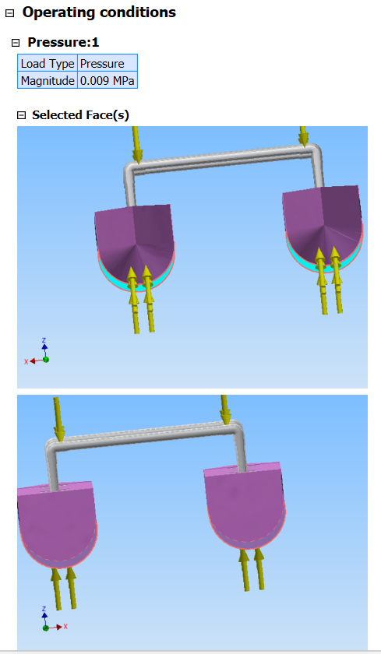

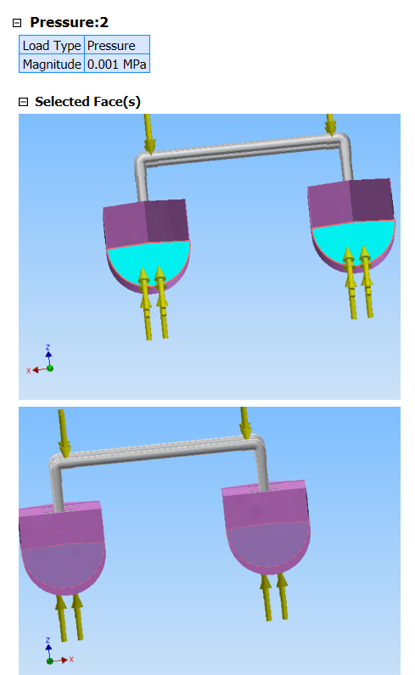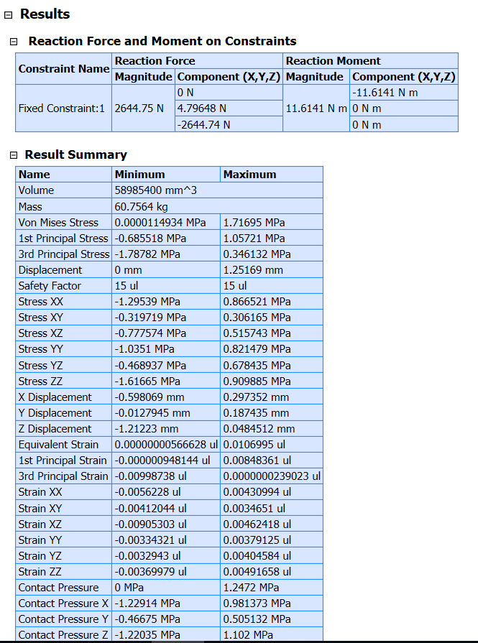

1. Conclusion.

By the end of the project, conclude the project and your learning experience.

Acknowledgement

If you get help or support from someone else (besides the team member and the advisor) and want to show your appreciation, put here (**do not include the advisor**).

Appendix

You can put reference info here, including: i) specs of components used in the system, ii) source code (must be here but not in the body text), iii) CAD figures, etc.

1. Component Specs
2. Specs of Arduino Due

...

1. Specs of Raspberry Pi

…

1. Source Code.
2. Source Code of Graphic User Interface

…

1. Source Code of Robotic Arm

…

REFERENCES

[1] Evans, R. C. (n. d.). *How a sail boat sails into the wind*. Retrieved from

http://web.mit.edu/2.972/www/reports/sail_boat/sail_boat.html

Marsh, M. B. (2012). *Understanding monohull sailboat stability curves*. Retrieved from

http://marine.marsh-design.com/content/understanding-monohull-sailboat-stability-curves

D. Vantrease, R. Schreiber, M. Monchiero, M. McLaren, N. P. Jouppi, M. Fiorentino*, et al.*, "Corona: System Implications of Emerging Nanophotonic Technology," in *Computer Architecture, 2008. ISCA '08. 35th International Symposium on*, 2008, pp. 153-164.

[2] X. Zhang and A. Louri, "A multilayer nanophotonic interconnection network for on-chip many-core communications," in *Design Automation Conference (DAC), 2010 47th ACM/IEEE*, 2010, pp. 156-161.

[3] C. Batten, A. Joshi, J. Orcutt, A. Khilo, B. Moss, C. Holzwarth*, et al.*, "Building manycore processor-to-DRAM networks with monolithic silicon photonics," in *High Performance Interconnects, 2008. HOTI '08. 16th IEEE Symposium on*, 2008, pp. 21-30.

[4] Y. Pan, P. Kumar, J. Kim, G. Memik, Y. Zhang, and A. Choudhary, "Firefly: illuminating future network-on-chip with nanophotonics," in *IEEE/ACM Intl. Symp. on Computer Architecture (ISCA)*, 2009, pp. 429-440.

[5] N. Kirman, M. Kirman, R. K. Dokania, J. F. Martinez, A. B. Apsel, M. A. Watkins*, et al.*, "Leveraging Optical Technology in Future Bus-based Chip Multiprocessors," in *Microarchitecture, 2006. MICRO-39. 39th Annual IEEE/ACM International Symposium on*, 2006, pp. 492-503.

[6] J. M. Cianchetti, C. J. Kerekes, and H. D. Albonesi, "Phastlane: a rapid transit optical routing network," in *Proceeding of: 36th International Symposium on Computer Architecture (ISCA)*, 2009, pp. 441-450.

[7] A. Shacham, K. Bergman, and L. P. Carloni, "Photonic Networks-on-Chip for Future Generations of Chip Multiprocessors," *Computers, IEEE Transactions on,* vol. 57, pp. 1246-1260, 2008.

[8] A. Shacham, K. Bergman, and L. P. Carloni, "On the Design of a Photonic Network-on-Chip," in *First International Symposium on Networks-on-Chip, 2007. NOCS 2007*, 2007, pp. 53-64.

[9] M. Kwai Hung, Y. Yaoyao, W. Xiaowen, Z. Wei, L. Weichen, and X. Jiang, "A Hierarchical Hybrid Optical-Electronic Network-on-Chip," in *VLSI (ISVLSI), 2010 IEEE Computer Society Annual Symposium on*, 2010, pp. 327-332.

[10] D. Ding and D. Z. Pan, "OIL: a nano-photonics optical interconnect library for a new photonic networks-on-chip architecture," presented at the Proceedings of the 11th international workshop on System level interconnect prediction, San Francisco, CA, USA, 2009.

[11] A. Joshi, C. Batten, K. Yong-Jin, S. Beamer, I. Shamim, K. Asanovic*, et al.*, "Silicon-photonic clos networks for global on-chip communication," in *Networks-on-Chip, 2009. NoCS 2009. 3rd ACM/IEEE International Symposium on*, 2009, pp. 124-133.

[12] D. Vantrease, R. Schreiber, M. Monchiero, M. McLaren, N. P. Jouppi, M. Fiorentino*, et al.*, "Corona: system implications of emerging nanophotonic technology," in *Proc. 35th IEEE/ACM Int'l Symp. Computer Architecture (ISCA)*, 2008, pp. 153-164.

[13] L. Zhang, E. Regentova, and X. Tan, "A 2D-Torus Based Packet Switching Optical Network-on-Chip Architecture," presented at the *IEEE International Symposium on Photonics and Optoelectronics* (SOPO 2011), Wuhan, China, 2011.

[14] L. Zhang, E. E. Regentova, and X. Tan, "Packet switching optical network-on-chip architectures," *Comput. Electr. Eng.,* vol. 39, pp. 697-714, 2013.

[15] G. Huaxi, X. Jiang, and W. Zheng, "A novel optical mesh network-on-chip for gigascale systems-on-chip," in *Circuits and Systems, 2008. APCCAS 2008. IEEE Asia Pacific Conference on*, 2008, pp. 1728-1731.

[16] G. Huaxi, X. Jiang, and Z. Wei, "A low-power fat tree-based optical Network-On-Chip for multiprocessor system-on-chip," in *Design, Automation & Test in Europe Conference & Exhibition, 2009. DATE '09.*, 2009, pp. 3-8.

[17] Y. Yaoyao, X. Jiang, H. Baihan, W. Xiaowen, Z. Wei, W. Xuan*, et al.*, "3-D Mesh-Based Optical Network-on-Chip for Multiprocessor System-on-Chip," *Computer-Aided Design of Integrated Circuits and Systems, IEEE Transactions on,* vol. 32, pp. 584-596, 2013.

[18] A. Shacham, K. Bergman, and L. P. Carloni, "Photonic networks-on-chip for future generations of chip multiprocessors," *IEEE Trans. Computers,* vol. 57, pp. 1246-1260, 2008.

[19] A. W. Poon, F. X. Xu, and X. Luo, "Cascaded active silicon microresonator array cross-connect circuits for WDM networks-on-chip," in *Proc. SPIE*, 2008, p. 689812.

[20] M. Lipson, "Compact Electro-Optic Modulators on a Silicon Chip," *IEEE Journal of Selected Topics in Quantum Electronics,* vol. 12, pp. 1520-1526, 2006.

[21] M. Lipson, "Guiding, modulating, and emitting light on Silicon-challenges and opportunities," *Lightwave Technology, Journal of,* vol. 23, pp. 4222-4238, 2005.

[22] T. Xianfang, Y. Mei, Z. Lei, J. Yingtao, and Y. Jianyi, "Wavelength-routed optical networks-on-chip built with comb switches," in *Photonics Conference (IPC), 2013 IEEE*, 2013, pp. 46-47.